**Statistics - Assignment 6 (Discrete Distributions)**

**EXERCISE 1.**Create a binomial **cumulative** distribution table for *n=10* using Python *scipy.stats*.

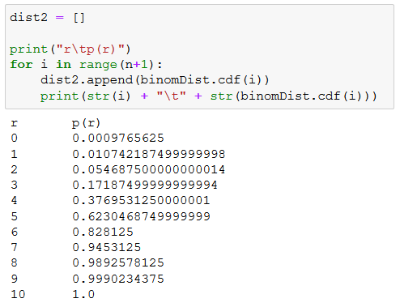

**EXERCISE 2.**Answer the following questions by looking at the distribution table or coding with Python.

1. P(1) = 0.3

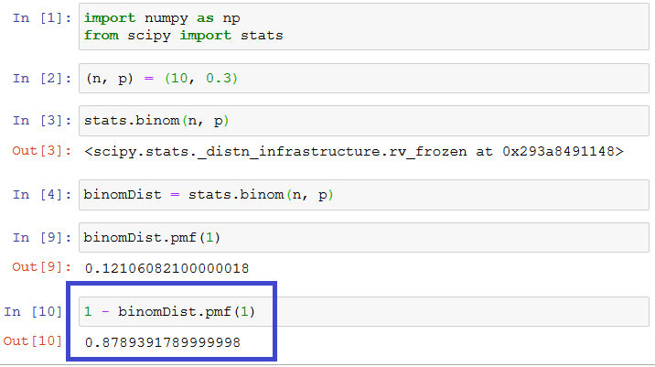

2. Ten coins are tossed simultaneously. Find the probability of getting:

This will be a binomial distribution with 10 trials and 0.5 probability.

1. at least seven heads:

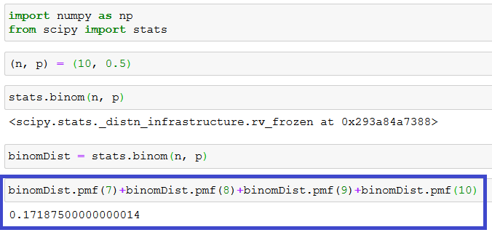

1. exactly seven heads:

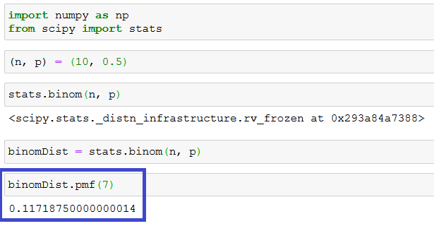

1. at most seven heads:

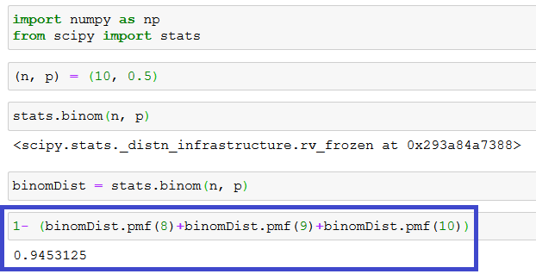

**EXERCISE 3.** Answer the following questions by looking at the distribution table or coding with Python.

1. A type of tree has seedlings dispersed in a large area with a mean density of five seedlings per square yard. What is the probability that none of ten randomly selected one-square yard regions have seedlings?

lambda = 5 x = 0 for ten times

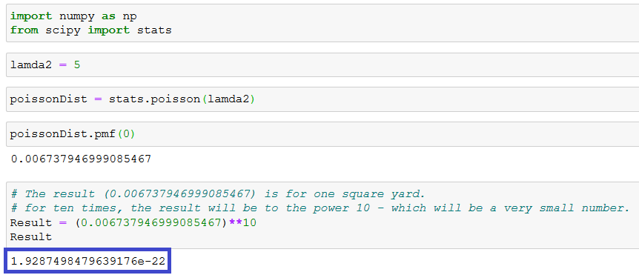

1. Let Y denote a random variable that has a Poisson distribution with mean *λ = 2*. Find  
   (i) *P(Y = 4)*

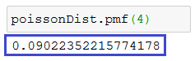

(ii) *P(Y ≥ 4)*

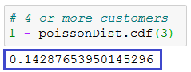

(iii)*P(Y < 4)*

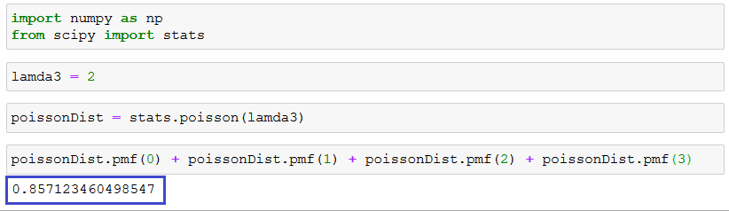

(iv)*P(Y ≥ 4 | Y ≥ 2 )*

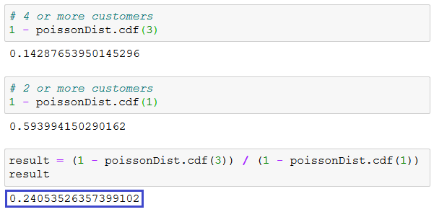

**EXERCISE 4.**Consider binomial experiment for *n = 20*, *p = .05*.

Binomial probabilities for *Y = 0, 1, 2, 3, and 4*. are:

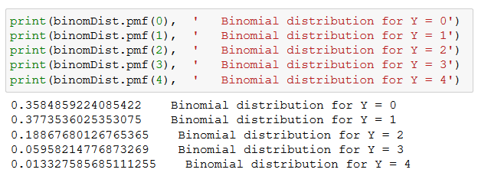

Same probabilities by using the Poisson approximation with *λ = np* are:

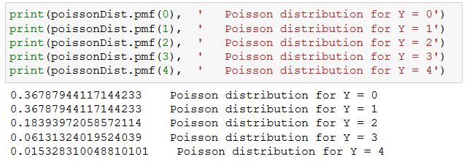

As a comparison, percentage difference between the Poisson and Binomial values are:

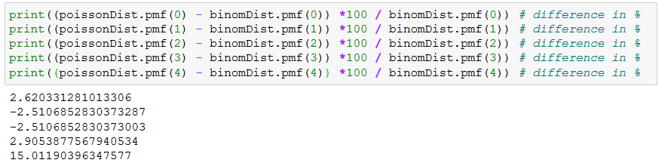

And the following are the differences between Poisson and Binomial values:

